SOFE2800

Lab 4 Report

group 5

Kevin, Arda, Jasindan, Darron, Ashwin

**Group Information**

Group #: 5

Members:

* Kevin Apuyan - 100561117
* Arda Celik - 100596185
* Jasindan Rasalingam - 100584595
* Darron Singh - 100584624
* Ashwin Kamalakannan - 100584423

**Website Information**

IP address: [54.167.245.220](http://54.167.245.220/)

Domain: <http://www.uoiteng.me/>

Description: The uoiteng.me website is designed to be a hub for Uoit engineering students. Our site contains a homepage with information regarding events currently happening in the university. The site has a forum that students can use to ask questions related to assignments and other course work. The site also has an analytics page showing the number of active users on the site at any given time, the browser the users are on and their general location.

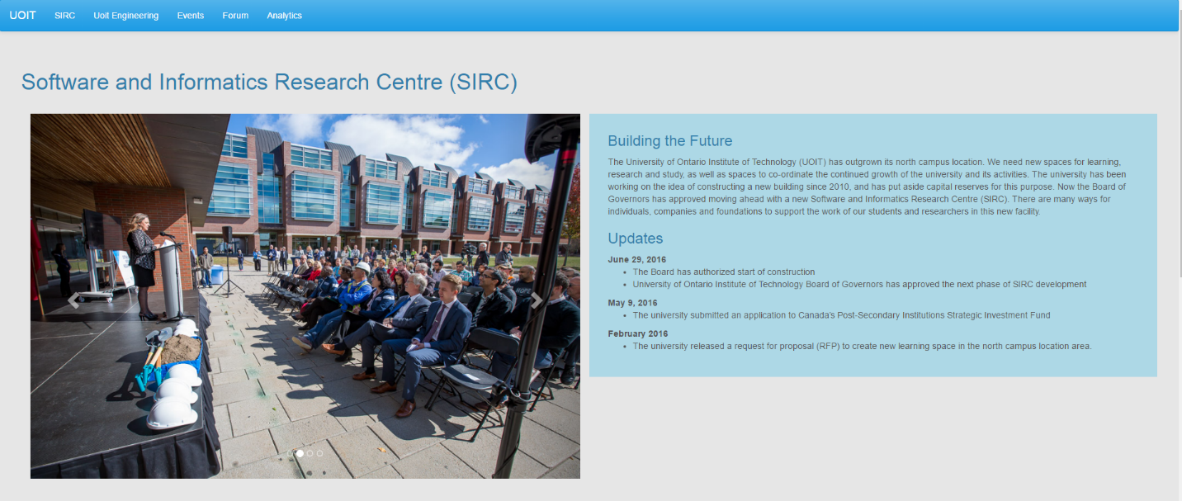

Figure 1: SIRC Section of the website provides a brief description of the new research center being built on campus while providing a slideshow of pictures from the information session



Figure 2: The “Engineering at UOIT” section provides a brief description of the Capstone Project and what students are expected to do. This section also includes an embedded video that summarizes the Capstone Project



Figure 3: The "Upcoming Events" section provides a table of upcoming events that are happening on campus

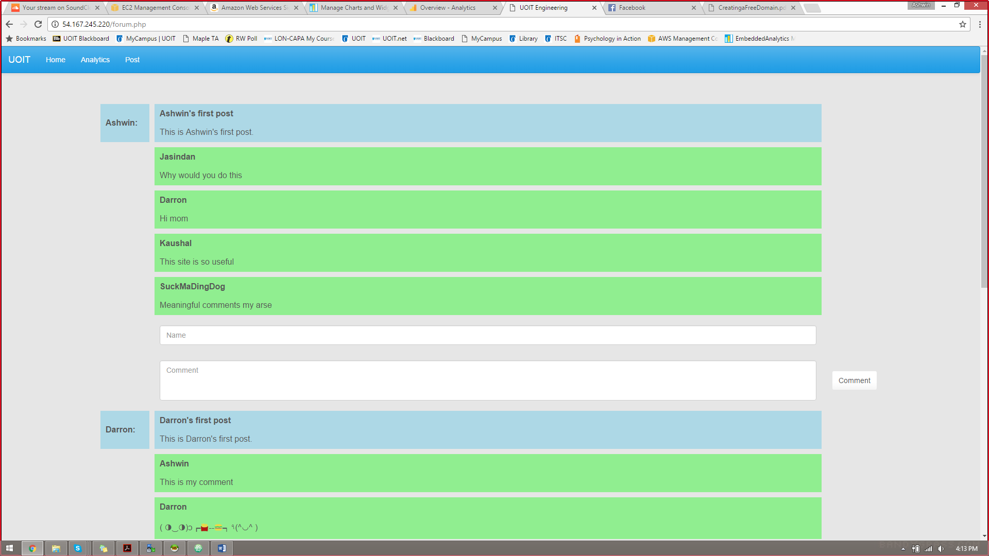

Figure 4: The Forum section of the website allows users to create posts and post comments on various topics of discussion

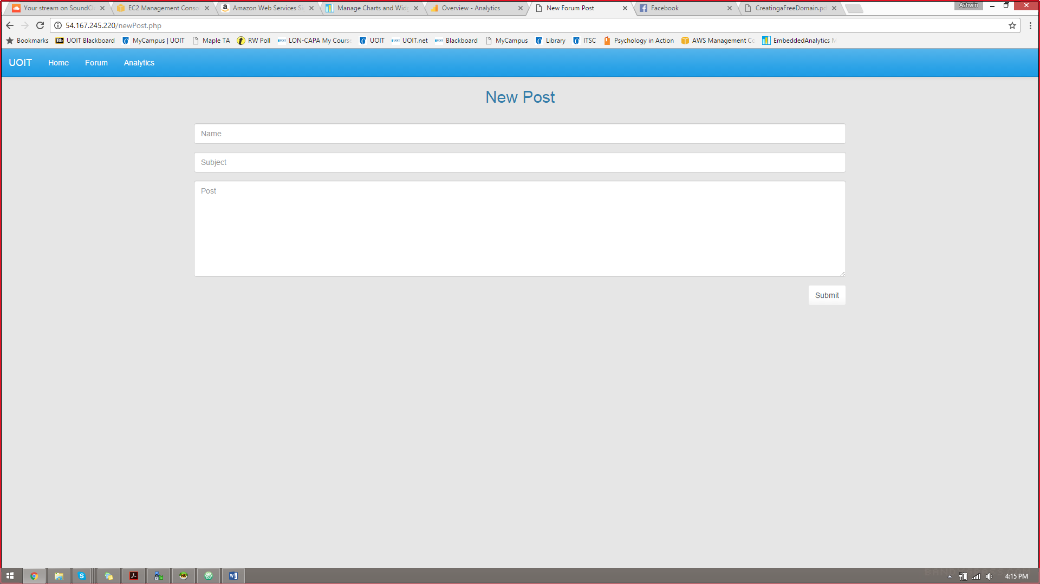

Figure 5: New Post page allows the user to create a new entry for the Forum page. Before the entry can be submitted, the data must be inputted in the correct format

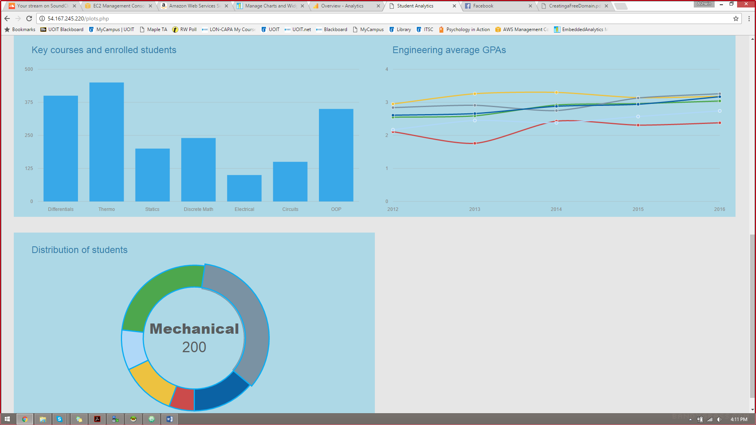

Figure 6: The lower half of the Analytics page contains graphs showing distribution of students, average GPAs over time and key course information

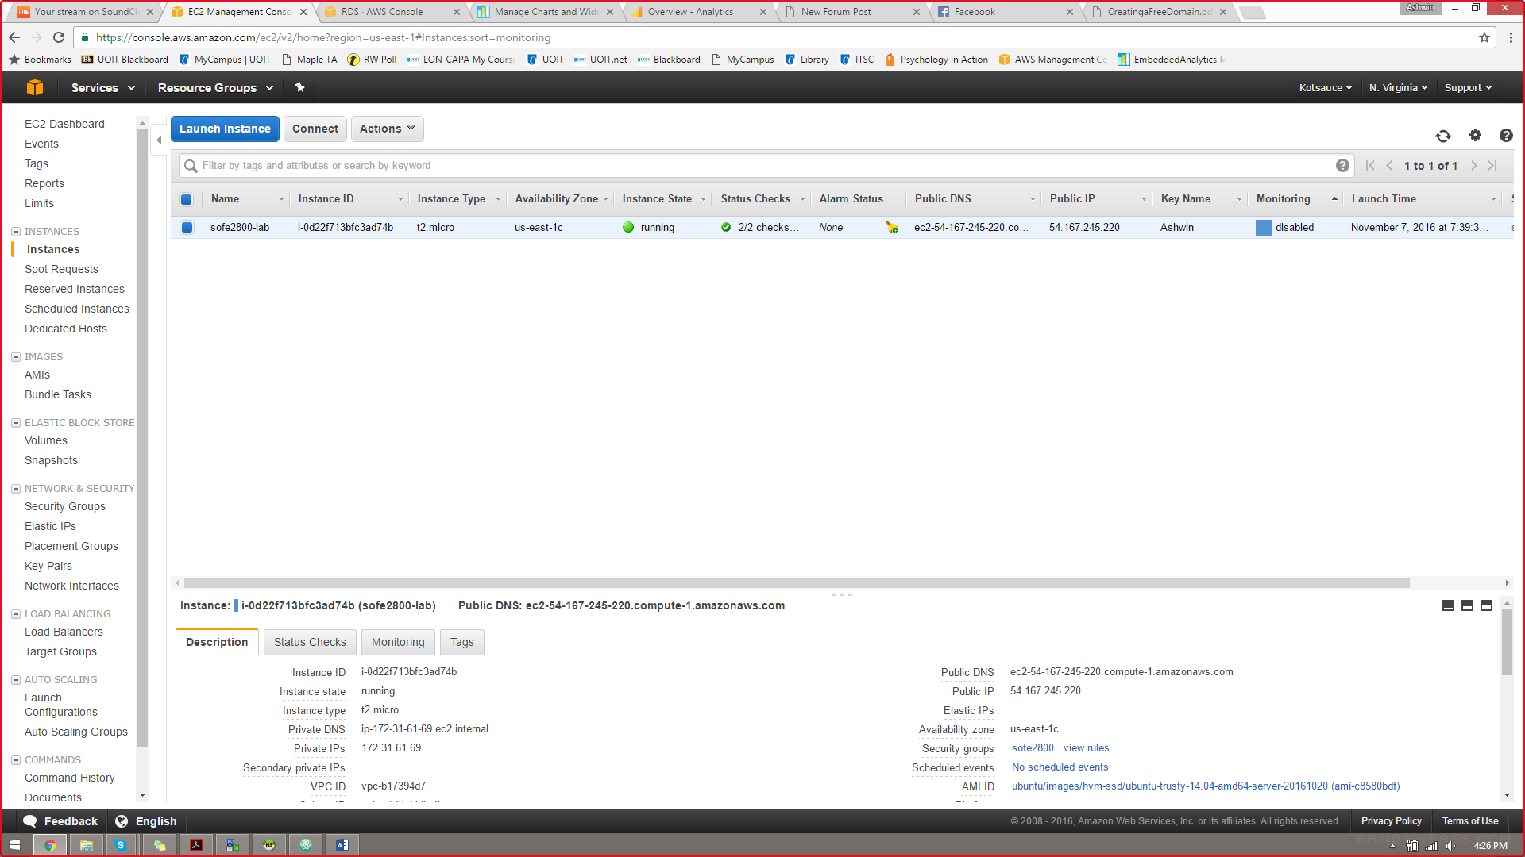

Figure 7: EC2 dashboard from Amazon web services

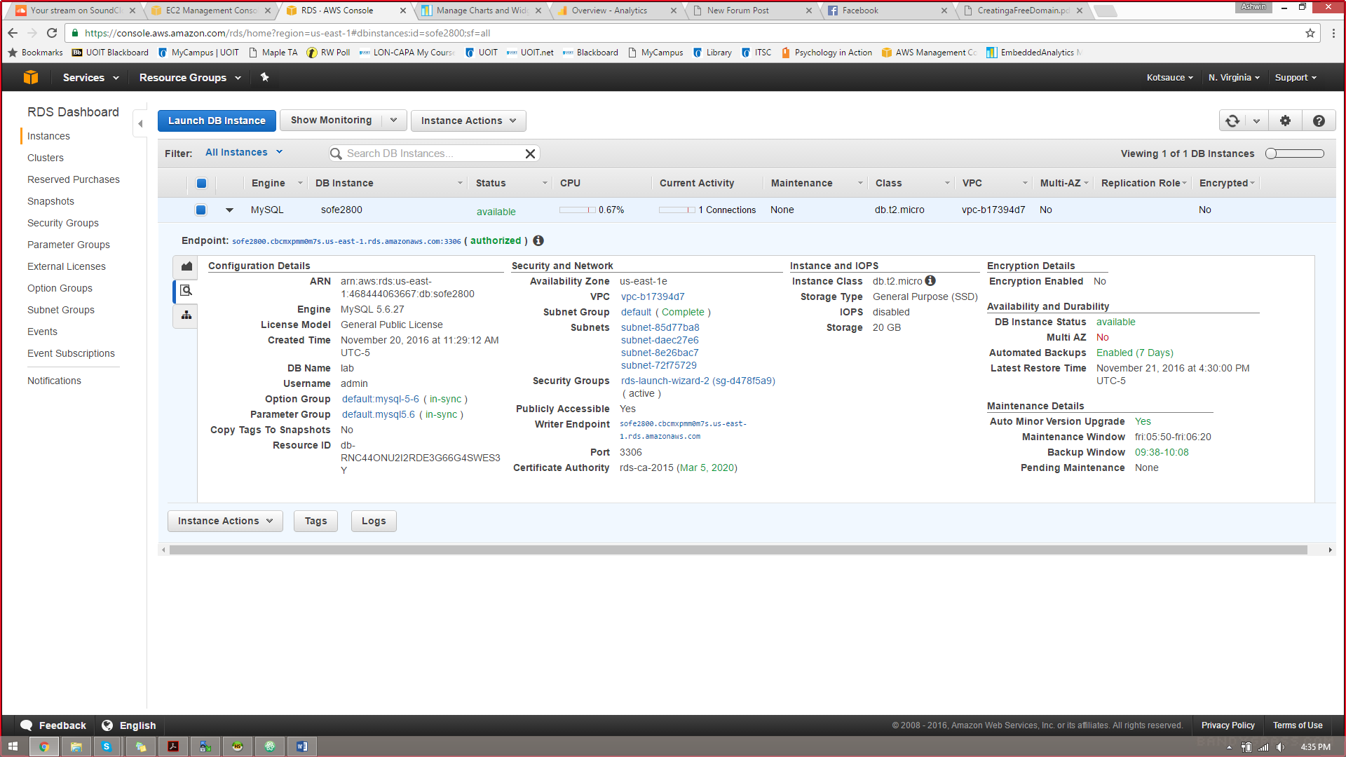

Figure 8: RDS dashboard from Amazon web services

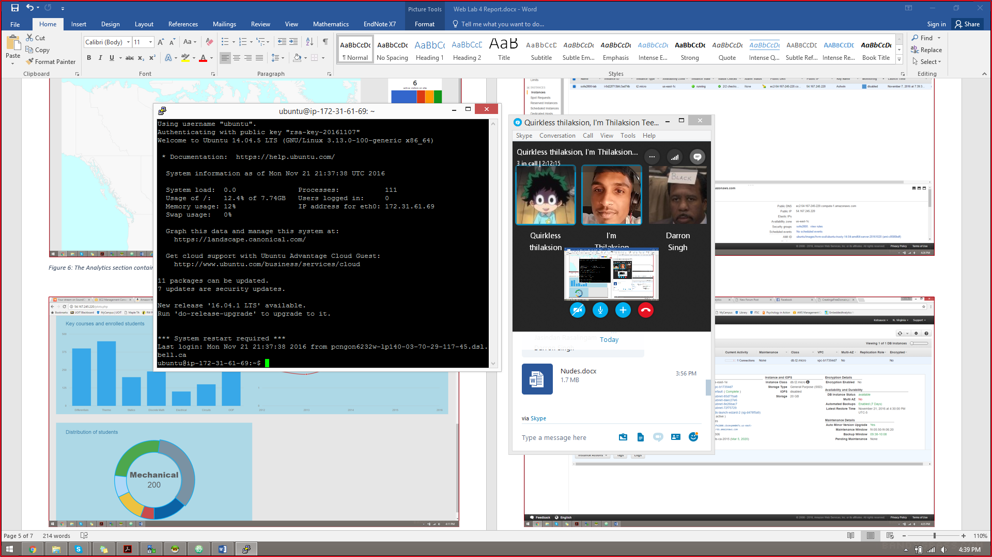

Figure 9: Ubuntu Linux terminal used to connect to EC2 server

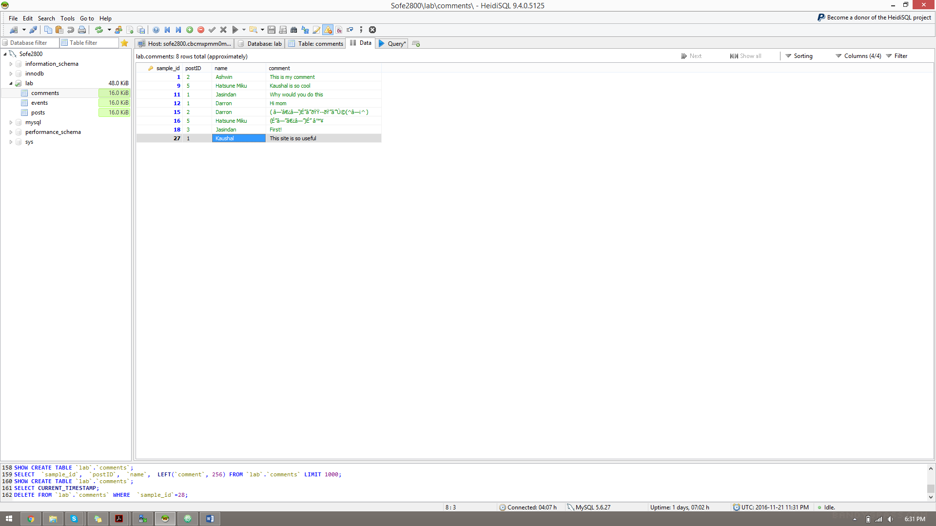

Figure 10: HeidiSQL program used to connect to our database. The database can also be modified using this program

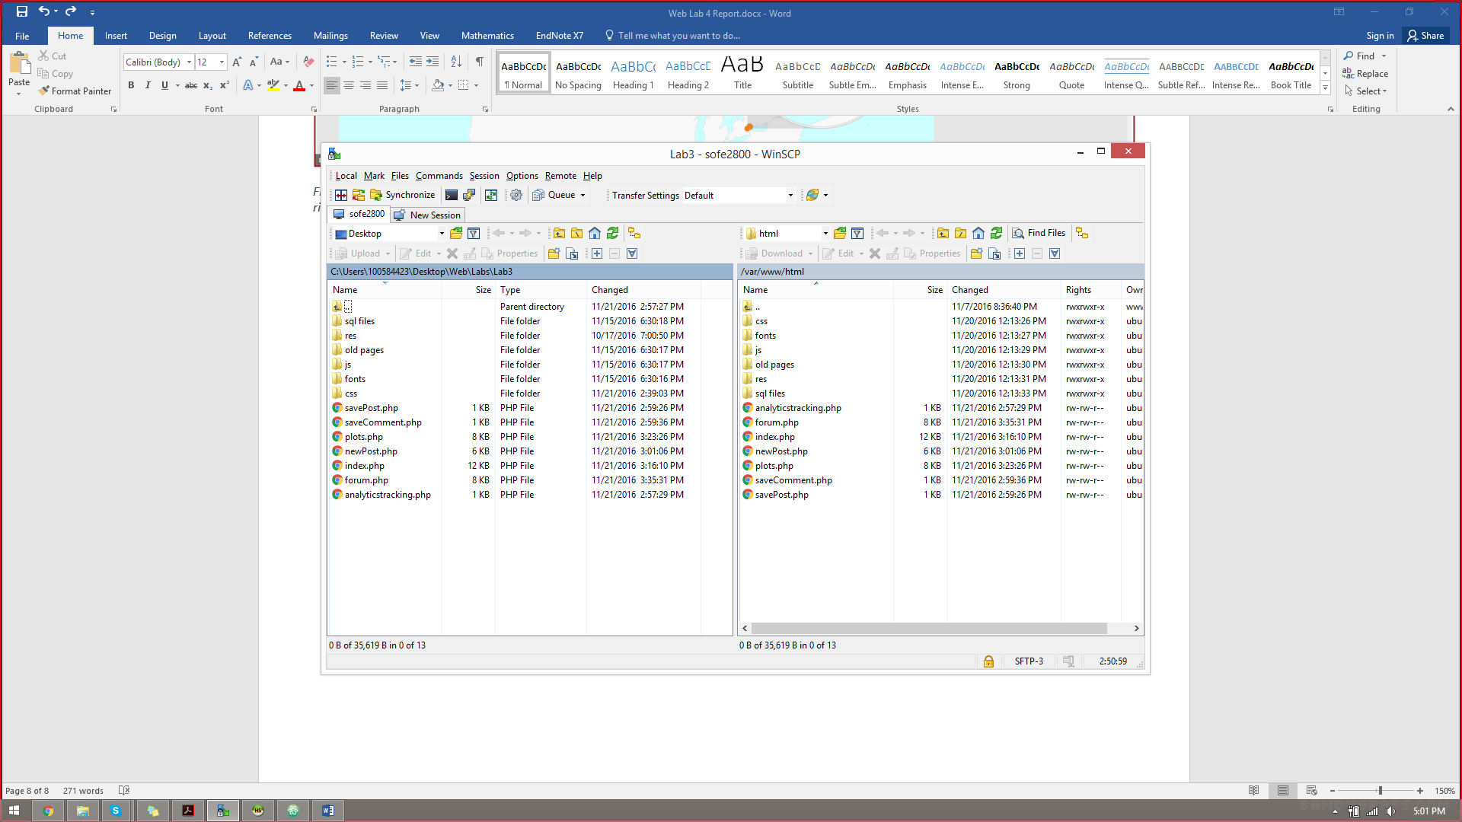

Figure 12: WinSCP program used to transfer files from local storage to web server and keep those files synchronized

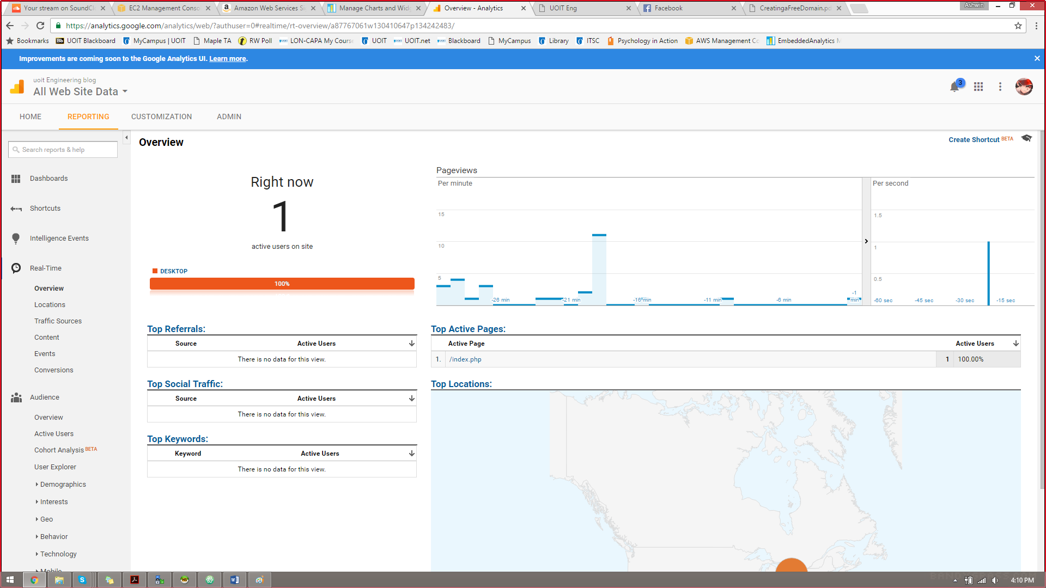

Figure 13: Google Analytics live dashboard showing location and platform data for active users

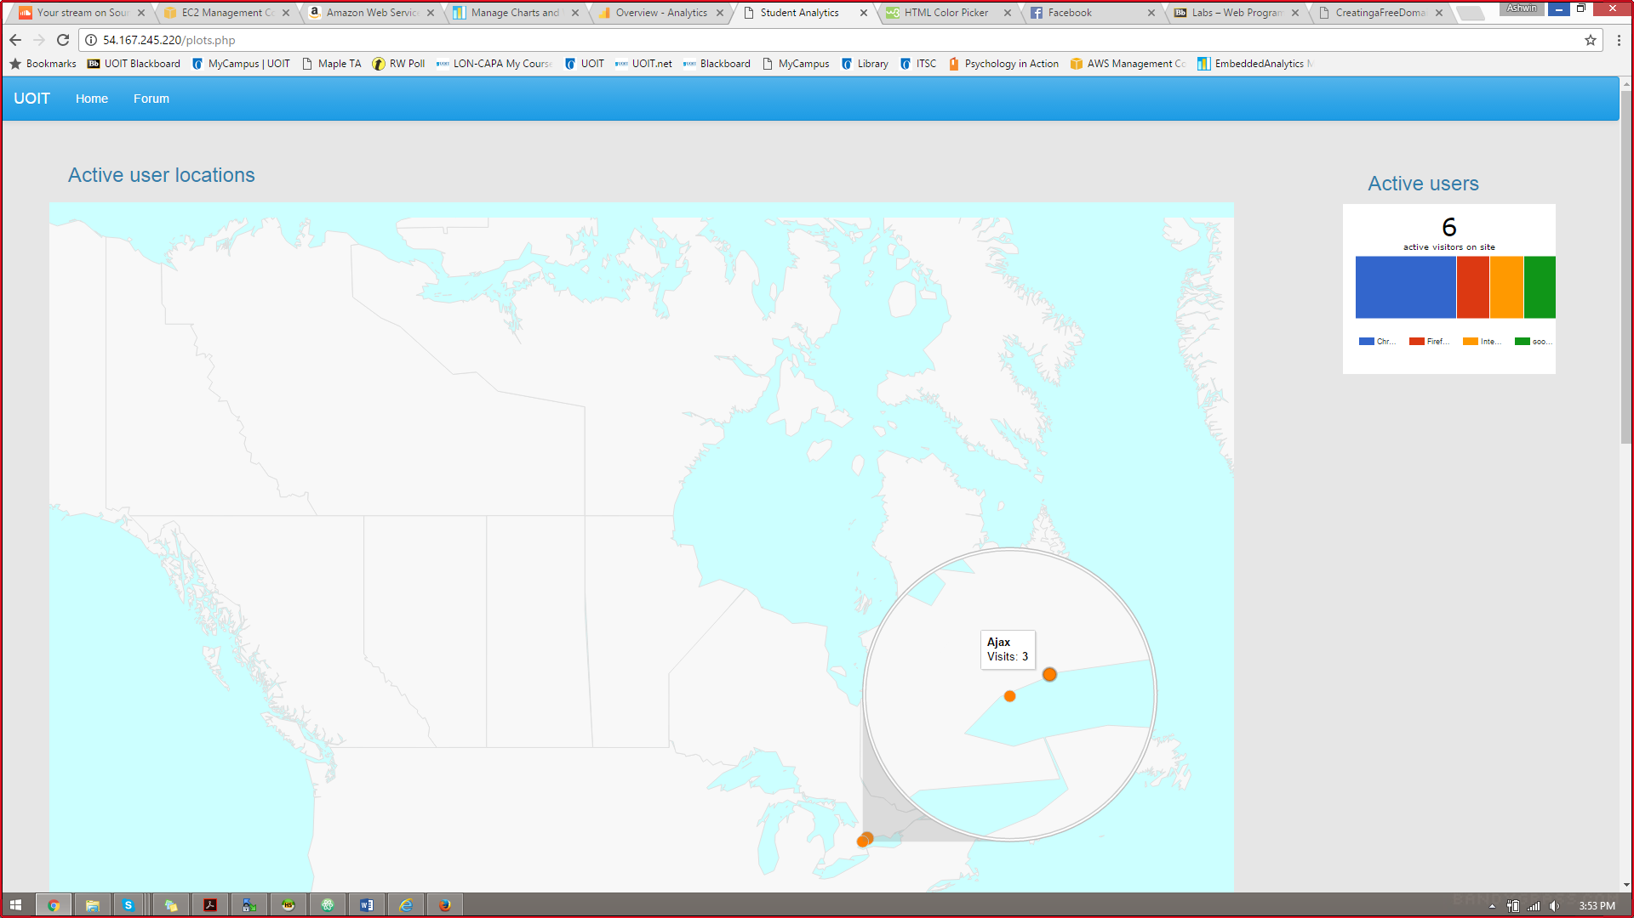

Figure 14: The Analytics page contains a map showing where active users are located by city. The number of active users can be found in the top right corner, as well as information on their browsers.

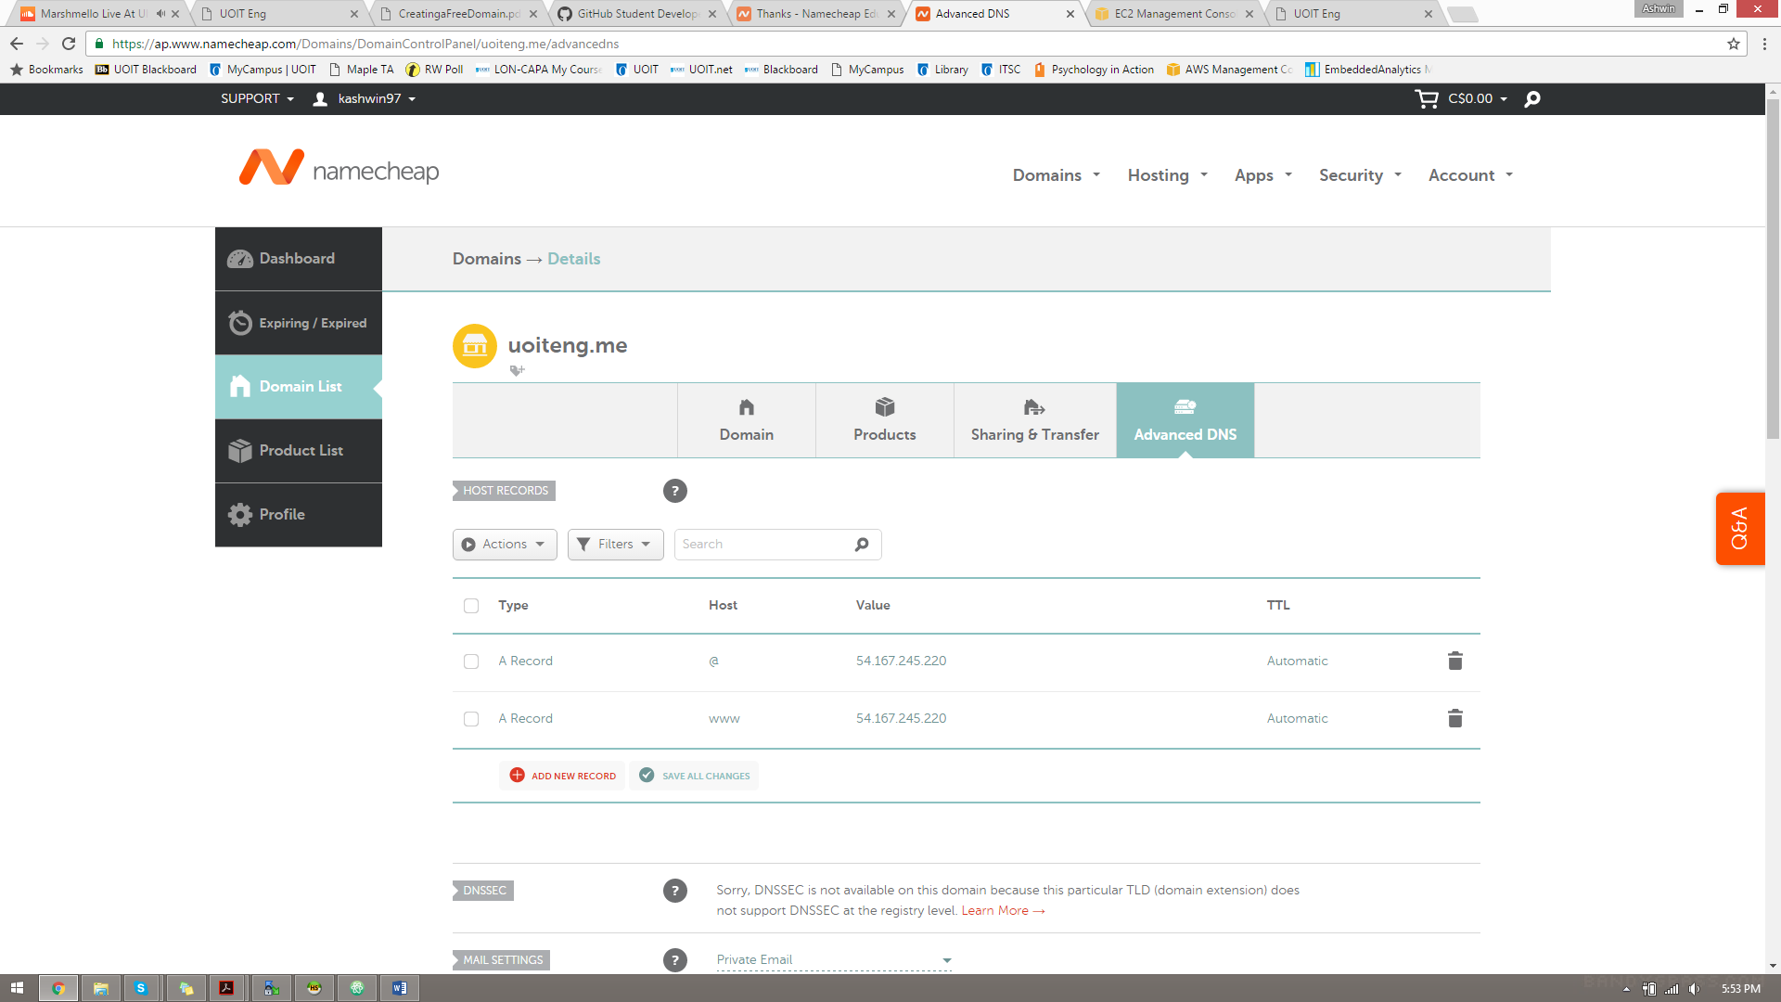

Figure 15: Domain name setup from namecheap with GitHub

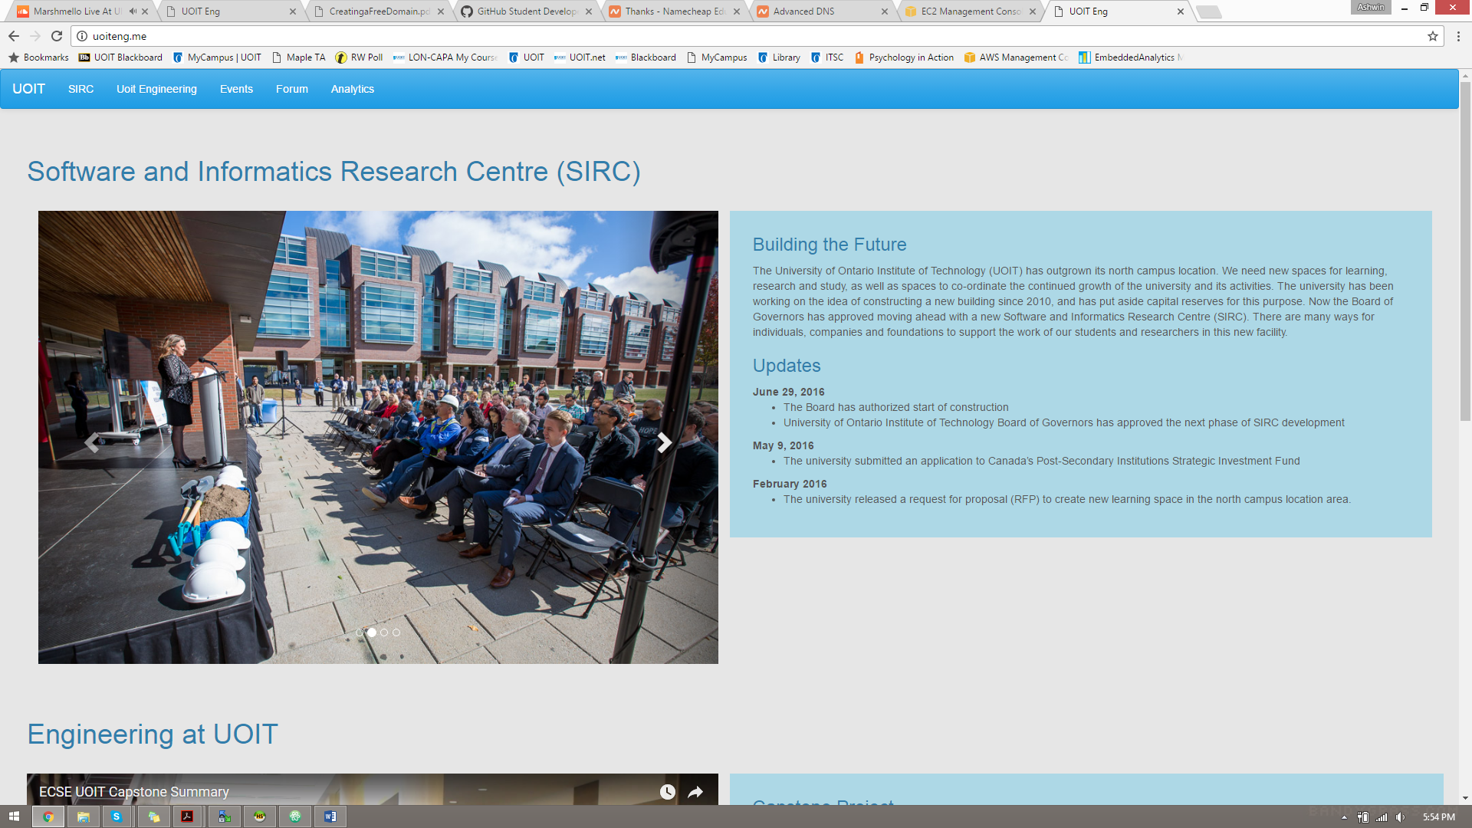

Figure 16: Our website working using the 'uoiteng.me' domain name